Image

**SheVANA ASC Minutes – February 14th***, 2022*

**CALL TO ORDER**

Meeting opened by Stephen P with moment of silence, 12 traditions (read by Paul G ), 12 Concepts (Dan C) and Shevana Purpose (Chris E)

|  |  |  |  |
| --- | --- | --- | --- |
| **FIRST ROLL CALL** | | | |
| **Group Name** | **Present Last ASC?** | **Representative / Title** | **Status** |
| Experience Strength & Hope | Yes | Randy D – GSR Fill In | Present |
| Eyes To The Sky | INACTIVE | Rick - GSR | Present |
| Finding a New Way to Live | Yes |  | Absent |
| Fire, Faith and Fellowship | INACTIVE |  | INACTIVE |
| Last Connection | Yes | Chris M - GSR | Present |
| Men’s Meeting | INACTIVE |  | INACTIVE |
| Midday NA | Yes | ViJay H - GSR | Present |
| NA@ Millcreek | INACTIVE |  | INACTIVE |
| New Chance | Yes | Bill M- GSR | Present |
| New Freedom | INACTIVE | Lee B- GSR Fill In | Present |
| N.O.A.N.D.A. | No | Liz C - GSR | Present |
| Out of the Cage | Yes |  | Absent |
| Recovery and Beyond | No | Dan C - GSR | Present |
| Regardless Of | Yes | Brandon R- GSR Alt | Present |
| Save Uranus | Yes | Kenny D - GSR | Present |
| Sisters in Spirit | INACTIVE | Barbara S - GSR | Present |
| Solution Seekers | No | Paul G | Absent |
| War Is Over | INACTIVE |  | Present |
| Welcome Home in Recovery | INACTIVE |  | INACTIVE |
| Renegade Meeting | Yes | Noah M– GSR Alt | Present |

***Active 14 Inactive 4 Present 13 Quorum was reached***

**EXECUTIVE REPORTS**

**Chair** Stephen P – Present Written Report

Dear ASC, Hope all is well and everyone had a great Christmas and New Year. I have been keeping my eyes open about the Lit account but still as of today not received any letter from Credit Control. I did reach out and as if they had send the hard copy our and they said it was mailed to the physical address on file. I again asked if they could send anther copy to the PO Box that I asked it to be sent to the first time and the told me they would. Still no Check from NAWS that was made out to the Lit Account for the over charge. I am trying everything I can to get to the solution with this but as you see its a waiting game. So more will be reviled when it’s reviled to me. I attend the Special Event NYE party and it was a blast! It was good to see all the people come tougher and I hope more events like this will be in the future. Please be patient tonight as it is nomination night and all positions are open. I appreciate it. I was also happy to see the turn out to ASC last month and I also hope this keeps up. Love you guys. P.S. The lock was removed off the Locker last month so we are done with that now. ILS, Stephen P

**Vice Chair:** Vacant

**Secretary:** Michelle M Present Written Report

Hello Family,

The December minutes were recorded and sent per policy.  I have enjoyed my time as Secretary over the last 2 year.  I am proud of this boby for navigating thru covid and getting things done for our area.  I am excited to see what service position my higher power throws at me next.  I looked over the minutes from 2020 to present we only had one polciy change.

Motion: 2020-01-04

1) To amend Section 12.6 SheVANA Regional Committee Member (RCM) to add the following duty:

Serve as a signatory on the ASC bank account.

Motion: 2020-02-04

2) To amend Section 12.7 RCM-Alt to add the following duty:

Serve as a signatory on the ASC bank account.

In Loving Service,

Michelle M

**RCM:** Chris M. Present No Written Report

Hello family

I attended RSC on 12/18/21 there were 7 areas in attendance.

Open positions are vice Tresurer, speaker jam chair

The April GSR assembly is scheduled for April 16th and 17th

Flyer coming soon

Interim CAR/CAT workshops

Are February 20th@2 pm

March 5th @ 10am

Flyer to come shortly

Motion Number 111-2

 Date: December 18th 2021

Mover: RD Team Area: NP Amendment Second Beach RCM

Motion: To change 6A Regional Delegate Duties #4. from: 4. Attends biennial World Service Conference (WSC) Meeting, Ca usually end of April; attends annual Mid-Atlantic Regional Conference of NA (MARLCNA) Lancaster, PA, on conferen Attends Zonal Forum Meetings (twice per year), locations vary from throughout the Autonomy Zone geographic ran organizes and chairs Zonal Forum when it is hosted by Central Atlantic Region); organize, schedule, coordinates and WSC Conference Agenda Report (CAR) Workshops throughout CARNA geographical area. (119th) To allow the deleg to attend in non-conference year the nearest World Wide Workshop. (142nd) Change to: 4. •AƩends biennial World Service Conference (WSC) MeeƟng, usually in California, usually the end of April. •AƩends service event in the eastern US area focused on the CAR/CAT on conference year. •AƩends Autonomy Zonal Forum MeeƟngs (twice per year) locaƟons vary from throughout the affiliated Zone’s geographic range •Organizes and chairs Zonal Forum when it is hosted by Central AtlanƟc Region. •Organizes, schedule, coordinates and facilitates Conference Agenda Report (CAR)/ Conference Approval Track (CAT Workshops throughout the four quadrants in the Central Atlantic Region’s

geographical area. •AƩends one service event in the non-conference year. Ex. MZSS, FSS etc. (119th) To allow the delegate team to attend in non-conference year the nearest Service Event TBD. (142nd) •Deleg can determine whether the whole team attends same Service events or splits the events between them for the con year and non-conference year.

Amendment Area &RCM: _____________________________ Description/Background (Optional): Since the guidelines were updated there are more car/cat events that are being held other than MARLCNA. This change would allow the delegate team to determine which car/cat service events would give the most information and if this could not be determined to allow the delegate team to split up and attend other service events each. Also there are no world wide workshop being held by NA World Service. Intent: To update guidelines to reflect correct events and allow the delegate team the flexibility to determine which service events would best provide information and/or train our delegate team

Motion Number: 111-3 Date:

 December 18th 2021

Mover: RD Team Area Second: Tidewater RCM

Motion: Description/Background (Optional):

Conference participants came to a consensus to postpone the next World Service Conference until 2023 in the hopes that we will be able to meet in person at that time. The WSC will convene for a partial, interim, virtual meeting in 2022 to make decisions that are required by law and policy, as well as to decide on the Spiritual Principle a Day book, but the conference cycle this time will be three years, ending when the 2023 meeting closes. Experience has shown that continuity of trusted servants in a conference cycle helps to make the WSC more effective so we are encouraging regions and zones to consider making similar decisions related to the terms of their delegates and alternates- See Attached Letter in its entirety.

Intent:

To Continue with the same delegate team to preserve continuity and help the World Service Conference (WSC) be more effective.

Motion:

To suspend policy to extend the term of the Regional delegate only by four months to maintain continuity of trusted servants for the 2023 World Service Conference

Back to groups for a vote

Pro: We are extremely bless and confident in our Regional Delegate Teams Ability to review the slate of work shops available at this conference and making the best decisions on which will give us the best bang for our bucks.

No Cons on either motion

Thank you for allowing me to serve this past year I have learned a lot and hope to learn more.

ILS

Chris M

Open positions are

Treasurer

Vice Treasurer

Speaker jam chair

Vice chair

**RCM Alt:** Vacant

**VRCC Director:** Linda A. Present Oral Report

**VRCC Alt Director:** Archer C Absent No Report

**ELECTED AND APPOINTED REPRESENTATIVE REPORTS:**

**H&I Chair:**  Danny M Present Written Report

Hi family- H&I met as scheduled on Monday January 3rd, we had a couple new members, We are still going into two facilities at this time, All positions were up for nomination, the committee has nominated Linda A as chair, so we bring that nomination here to this body. Our next meeting will be monday February 7th at 7pm and our next handbook study will also be the 7th at 6 both at 303 south Loudoun at the back of the adams nelson building.

ILS, Danny M

**Literature Chair** Vi H Present Written Report

Hi,

3 of us got together and completed an inventory count. Stocks on several items are low and until we have our own bank account I am requesting $365.69 to buy tags, literature, and medallions. At the risk of sounding extremely inexperienced, which I am, I’m not sure if the quantities I’m requesting below are appropriate or not. I am open to adjusting the quantities if anyone would like to get with me to review current stocks as well as adjust the amounts before submission to treasurer.

Literature subcommittee will have its first meeting of the year this Saturday the 15th 2:00pm at Edge Hill. We are looking for members to help us with their experience, suggestions, and service. Hope to see you there!

**Newsletter Chair:** Vacant

**Outreach Chair:** Vacant

**Parliamentarian** – Vacant

**Public Relations Chair :** Lyle R Present Written Report

PR Report 1-10-2022

Greetings family,

Public Relations Subcommittee did not meet this month due to time constraints over the busy holiday season.  I plan on attending the Regional PR meeting this coming Saturday via Zoom.  I have included a powerpoint presentation for the secretary to attach to the minutes.  It covers the regional effort to run late night NA Hotline television ads.

I want to thank the Area for allowing me to serve as Public Relations Chair over the past year.  It has been a rewarding learning experience.  I begin college classes next week along with a full time work schedule.  One of my classes is Monday evening, which precludes me from attending ASC.  I’ll be more than happy to pass along my Public Relations knowledge to the next willing servant.

In Service, Lyle R.

**Special Events Chair:** Pro Temp Bill M – Written Report

The planned Shevana Special Event that was our NYE party went well. Hosted at Grace Downtown Church had a great turnout and grossed $190.00 with one request for reimbursement of $51.49 which we have asked our area chair and our area treasurer to cut a check in that amount from the SE checking account. Our previous balance of $600.00 and with the addition of $190.00, deposited in the SE checking account minus the reimbursement leaves $738.51 as our current balance. We deemed this a success not because of our bank balance but for our objective was met. We will meet again after the AVCNA for future events. Planning has already begun.

More will be revealed and straight ahead !

Love you all,

ILS Bill M-Pro tem

**OPEN POSITIONS:**

Literature – Open Vice Chair - Open

Parliamentarian – Open RCM Alt - Open

Outreach Chair – Open Newsletter Chair - Open

**QUESTIONS REGARDING REPORTS**

* What is this letter from the bank?
  + A hard copy from credit control that the previous negative balance has been taken care of this letter goes to the bank to open accounts that were closed due to negative balance
* Literature Process?
  + Needs to open a checking account
  + Maybe area gives upfront money to place order
  + Will discuss in new business
* Options for Literature account?
  + No account it has been closed and all monies deposited in the ASC master account

**CONCEPT OF THE MONTH:**

**Concept 1** Read by Chris M.

To fulfill our fellowship’s primary purpose, the NA groups have joined together to create a structure which develops, coordinates, and maintains services on behalf of NA as a whole.

**OPEN FORUM**

* Interim Conference Year
  + Virtual Conference
  + Will vote on 5 motions
  + 20th February and March 5 workshops
  + In person conference in 2023
* Adhoc for old archives
  + Will put under old business
* 39th AVCNA
  + Needs support

|  |  |  |  |
| --- | --- | --- | --- |
| **Second ROLL CALL** | | | |
| **Group Name** | **Present Last ASC?** | **Representative / Title** | **Status** |
| Experience Strength & Hope | Yes | Randy D – GSR Fill In | Present |
| Eyes To The Sky | INACTIVE | Rick - GSR | Present |
| Finding a New Way to Live | Yes |  | Absent |
| Fire, Faith and Fellowship | INACTIVE |  | INACTIVE |
| Last Connection | Yes | Chris M - GSR | Present |
| Men’s Meeting | INACTIVE |  | INACTIVE |
| Midday NA | Yes | ViJay H - GSR | Present |
| NA@ Millcreek | INACTIVE |  | INACTIVE |
| New Chance | Yes | Bill M- GSR | Present |
| New Freedom | INACTIVE | Lee B- GSR Fill In | Present |
| N.O.A.N.D.A. | No | Liz C - GSR | Present |
| Out of the Cage | Yes |  | Absent |
| Recovery and Beyond | No | Dan C - GSR | Present |
| Regardless Of | Yes |  | Absent |
| Save Uranus | Yes | Kenny D - GSR | Present |
| Sisters in Spirit | INACTIVE | Barbara S - GSR | Present |
| Solution Seekers | No | Paul G | Absent |
| War Is Over | INACTIVE |  | Present |
| Welcome Home in Recovery | INACTIVE | Wendy D - GSR | Present |
| Renegade Meeting | Yes | Noah M– GSR Alt | Present |

***Active 14 Inactive 4 Present 13 Quorum was reached***

* **CELEBRATIONS**
  + John D 1 Years Eyes to the Sky 1/11
  + Bruce C 27 Years Eyes to the Sky 1/27
  + Willie W 27 Years Out of the Cage 1/27
  + Thomas S 11 Years New Chance 2/3
  + Pat K 35 Years New Chance 2/10
  + Linda A 30 Years New Chance 2/17
  + Annette D 26 Years Experience, Strength, & Hope 2 /5
  + Randy D 26 Year Experience, Strength, & Hope 2/19
  + Christy S 1 Year Welcome Home in Recovery 2/1
* **ANNOUNCEMENTS**

AVCNA 39 January 21-23 Harrisonburg, VA

* **AREA OPEN POSITIONS & NOMINATIONS & ELECTIONS**

**OPEN POSITIONS:**

All Positions Open

Nominations:

Chair: Stephen P

* + - Qualifications:
      * Almost 10 years clean.
      * Have a home group and active in it.
      * I have a sponsor.
      * Been part of ASC 9 years.
      * Active Chair now.
      * Willing to be of service.

Vice Chair: Michelle M

* + - Qualifications:
      * 9.5 years clean
      * Have a sponsor that has a sponsor
      * Have held many service positions from the homegroup to the area to the VRCC
      * Working knowledge of traditions, concepts, and willing

Treasurer: Chris E

* + - Qualifications: Not sent to secretary

RCM: Chris M

* + - Qualifications: Not sent to secretary

Literature Chair: Vi N

* + - Qualifications: Not sent to secretary

PR Chair: Wendy D

* + - Qualifications:
      * I have a homegroup
      * I have 7 years clean,
      * I have a sponsor who has a sponsor & we do step work.
      * I’ve been chair of PR and part of the PR subcommittee since I’ve been clean.
      * I have also been chair of the area, & Secretary of the area.

Special Events Chair: Bill M

* + - Qualifications: Not sent to secretary

H & I Chair - Linda A – Nominated by H& I

* + - Qualifications:
      * Have not used for 29 years, 11 months
      * Member of h& I since 1995
      * Have been the panel coordinator
      * Have served as secretary of and on
      * Willing to learn the do’s & don’t;s of H&I
      * Willing to serve

**No Nominations for the following positions:**

* + Newsletter
  + Outreach
  + Secretary
  + Parliamentarian
* **OLD BUSINESS – None**
* **REGIONAL OPEN POSITIONS & MOTIONS –**

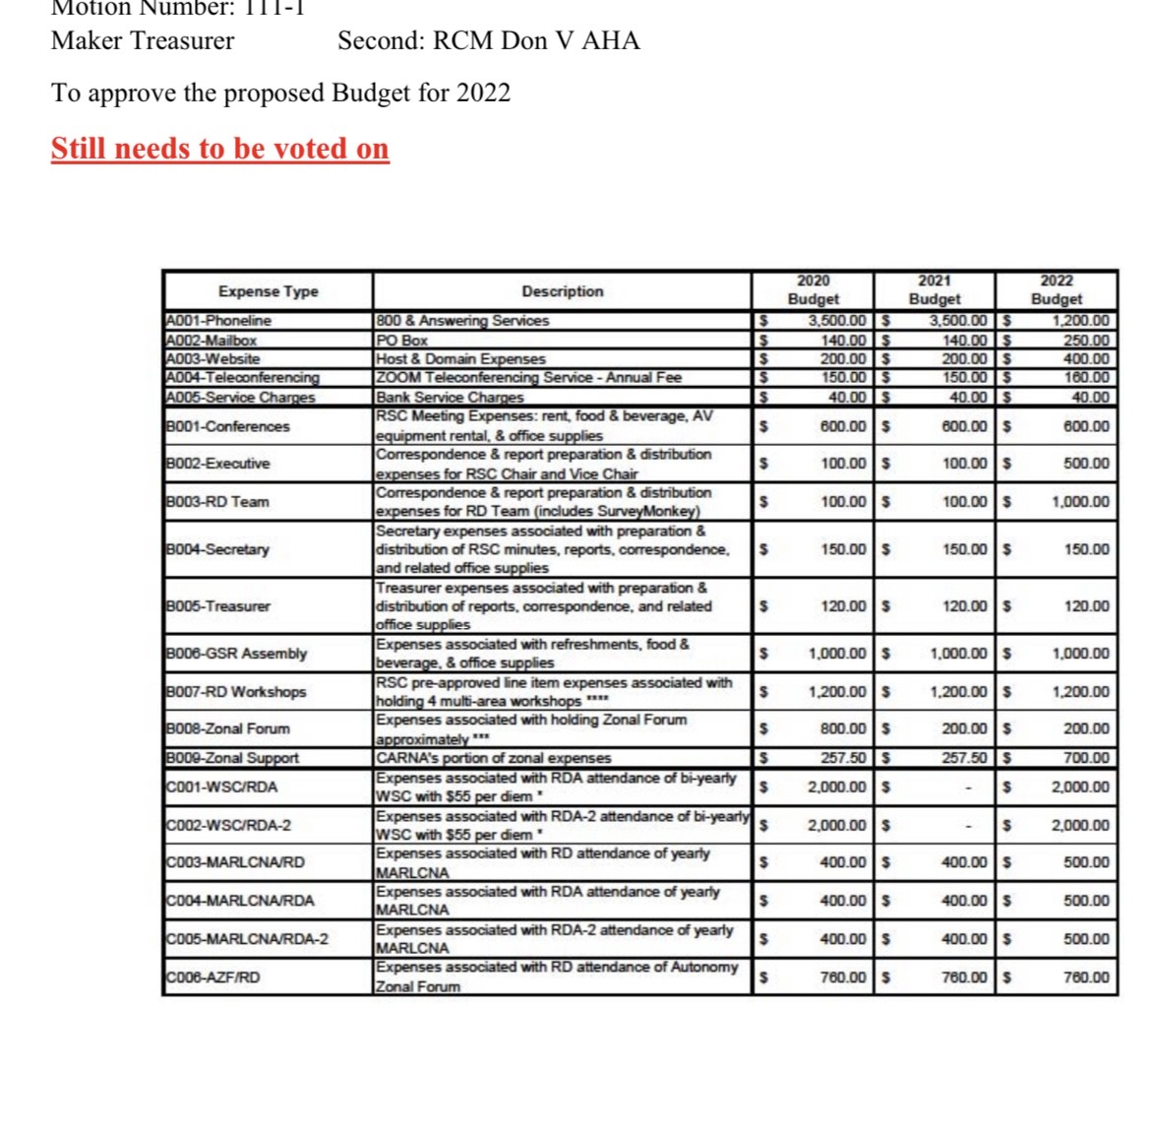

**Regional Open positions -**

Vice treasurer

Treasurer

Speaker jam chair

* **VRCC OPEN POSITIONS**

Vice treasurer

* **NEW BUSINESS –**

Motions: 01-01-22

Maker: Michelle M 2nd Lyle R

Motion: If a trusted servant position is responsible for a bank account, they will add the most current monthly bank statement to their report

Intent: For bank account transparency & accountability

* **BUDGET REQUESTS – None**

**TREASURERS REPORT** – Chris E -Present Written Report

January 2022 Treasurer’s Report

Starting Balance: $1422.54

Outgoing Funds:

$25.00 Adams nelson for H&I rent

$50.00 Grace community Church for ASC rent

Incoming Funds: $495.19 Donations

Ending Balance: $1842.73

Special Events

Starting Balance: $577.00

Incoming Funds: $190.00

Ending Balance: $767.00

Still have not gotten reimbursed by NAWS for overcharging us.

Thanks for allowing me to serve,

Chris E.

**NEXT ASC MEETING:** The next Area Service Meeting will be held on Monday, February 14th at 6:30 pm. @ Grace Community Church



***ASC MEMBER CONTACT INFORMATION***

|  |  |  |  |
| --- | --- | --- | --- |
| Barbara S. | 540-327-6134 | [Barbara.Sadhana@fema.dhs.gov](mailto:Barbara.Sadhana@fema.dhs.gov) | *Parliamentarian* |
| Chris A. | 571-450-0094 | [Chrisanders1089@gmail.com](mailto:Chrisanders1089@gmail.com) | *GSR-Last Connection* |
| Danny Mc. | 540-303-4936 | [Dannym246@gmail.com](mailto:Dannym246@gmail.com) | *H&I Chair* |
| Linda A. | 540-664-6077 | [cleanduetona@yahoo.com](mailto:cleanduetona@yahoo.com) | *VRCC Director* |
| Michelle M. | 540-532-9631 | [Ponylady90@hotmail.com](mailto:Ponylady90@hotmail.com) | *Secretary* |
| Randy D. | 540-322-3335 | [Der12296@comcast.com](mailto:Der12296@comcast.com) | *Alt GSR-Exp., Str., & Hope* |
| Archer C | 540-664-6752 | [acrebbs@aol.com](mailto:acrebbs@aol.com) | *GSR – Exp, Str, & Hope* |
| Peyton C | 804-302-3024 | [peytoncrebbs@yahoo.com](mailto:peytoncrebbs@yahoo.com) | *New Freedom* |
| Chris M. | 304-279-2966 | [Chrismauck84@yahoo.com](mailto:Chrismauck84@yahoo.com) | *RCM* |
| Emily K |  | Ekingq31@gmail.com | *GSR Midday* |
| Mike H. | 540-247-3426 | [Michaelkhorne1@gmail.com](mailto:Michaelkhorne1@gmail.com) | *GSR Noanda* |
| Lyle R. | 850-445-8203 | [lylearolfes@gmail.com](mailto:lylearolfes@gmail.com) | *GSR Regardless Of* |
| Jennifer S | 757-739-6015 | Shibley.jennifer@gmail.com | *GSR NOANDA* |
| Rachel F | 540-664-3937 | Franksrachel675@gmail.com | *GSR Eyes to the Sky* |
| David T | 540-514-5077 | Dtraub2408@gmail.com | *GSR – Solution Seekers*  *RCM* |
| Dave C |  | [Cleanbecuz_1@yahoo.com](mailto:Cleanbecuz_1@yahoo.com) | *GSR – Recovery & Beyond* |
| Faith O | 540-429-0914 | Faithowens88@aol.com | *Fire, Faith, Fellowship GSR Alt* |
| Liz C |  | elizabethchppll@yahoo.com | *GSR - Noanda* |
| Chris E | 540-323-0259 | Chrisesposito89@yahoo.com | *New Chance GSR*  *ASC Treasurer* |
| Stephen P | 540-539-2177 | stephen.price02@comcast.net |  |
| Paul G |  | pjgallagherjr@gmail.com | *Solutions Seekers – GSR Alt* |
| Erica B | 540-550-9562 | a4047@gmail.com | *GSR Alt Experience, Strength, & Hope* |
| Erica B |  | Erica4047@gmail.com |  |
| Kevin I | 202-944-0386 | jazirock@gmail.com | *GSR Renegade Meeting* |
| Bill M | 540-820-4225 | billmyersvalleyauto@gmail.com | *GSR New Chance Group* |
| Vijay H |  | Nairvihang@gmail.com | *GSR Midday* |
| Kenny D | 540-327-3160 | KENDARRLL@gmail.com | *GSR Save Uranus* |
| Julie M | 540-222-4497 | [Julie.grubbs@gmail.com](mailto:Julie.grubbs@gmail.com) | *GSR Finding a new way to live* |
| Noah M | 540-664-1459 | Noahmahoney1999@gmail.com | *GSR Alt Renegade* |
| Lee B | 540-532-5133 | [bowmanhomeremodeling@gmail.com](mailto:bowmanhomeremodeling@gmail.com) | *GSR Fill In – New Freedom* |
| Brandon R | 757-819-8777 | brandonrumbaugh@gmail.com | *GSR Alt – Regardless of* |
| Augusta W | 240-723-3315 | augustaweschler@gmail.com | *Renegade Fill In* |
| Wendy D | 540-303-1675 | Wj-horton@yahoo.com | *GSR – Welcome Home in Recovery* |